INVENTORY MANAGEMENT SYSTEM
A Mini Project Report
Submitted By: Abhinav
Submitted To: Prof. Shubham dubey
Department of Computer Science and Engineering
Academic Year: 2025–2026

1. Introduction
Inventory management plays a crucial role in retail, supply chain, warehouses, and business operations. This project focuses on building a simple, console‑based inventory system using the C programming language. The program maintains product information including ID, name, price, and stock.
The project uses key C concepts:
• Structures for grouping product information
• Arrays for storing multiple products
• Loops for repetitive operations
• Conditional statements for program flow control
• Switch-case statements for menu-driven systems

2. Problem Statement
Manual inventory tracking is error-prone and inefficient. Businesses require fast access to product information, such as available stock, product details, and pricing. This project solves the problem by creating a simple computerized system using C.

3. Objectives
The project aims to:
• Digitally manage inventory data
• Allow addition of new products
• Enable searching for products by ID
• Update the stock quantity easily
• Display all stored product details
• Provide a clear menu-driven interface

4. Proposed System
The proposed system is a text-based inventory management tool. Users interact through menu options. The system can manage up to 100 products and is efficient for small-scale inventory environments.

5. Methodology / Algorithm
Algorithm Steps:
1. Start program
2. Initialize inventory array and count variable
3. Display menu repeatedly in an infinite loop
4. Take user input (choice)
5. Perform selected operation
6. Repeat until user selects Exit

6. Program Design (Flowchart)
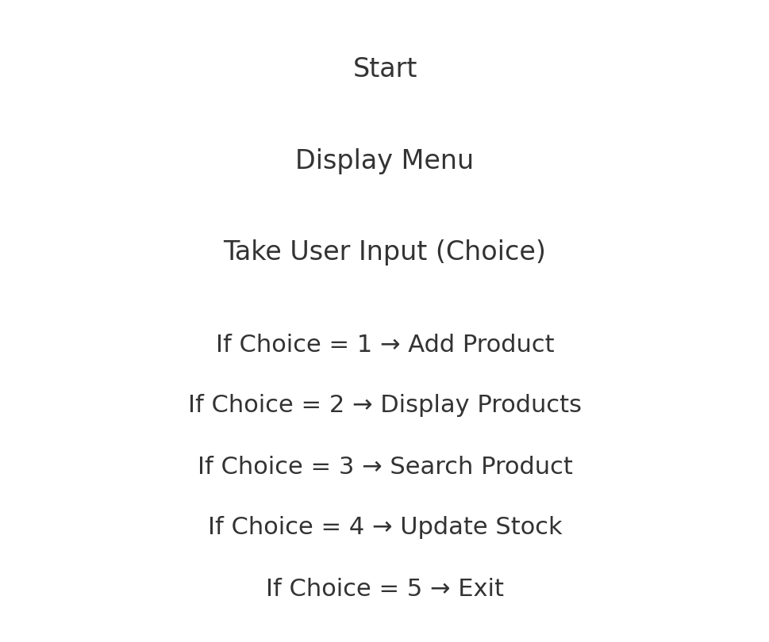

7. Implementation (C Code)
Full source code is included below:
#include <stdio.h>
#define MAX 100
struct Product {
int id;
char name[50];
float price;
int stock;
};
int main() {
struct Product inventory[MAX];
int count = 0, choice;
while (1) {
printf("\n=== Inventory Management System ===\n");
printf("1. Add Product\n");
printf("2. Display All Products\n");
printf("3. Search Product by ID\n");
printf("4. Update Stock\n");
printf("5. Exit\n");
printf("Enter your choice: ");
scanf("%d", &choice);
switch (choice) {
case 1:
// Add Product Code...
break;
case 2:
// Display Products...
break;
case 3:
// Search Product...
break;
case 4:
// Update Stock...
break;
case 5:
return 0;
}
}
}

8. Output
Below is a screenshot of sample output:
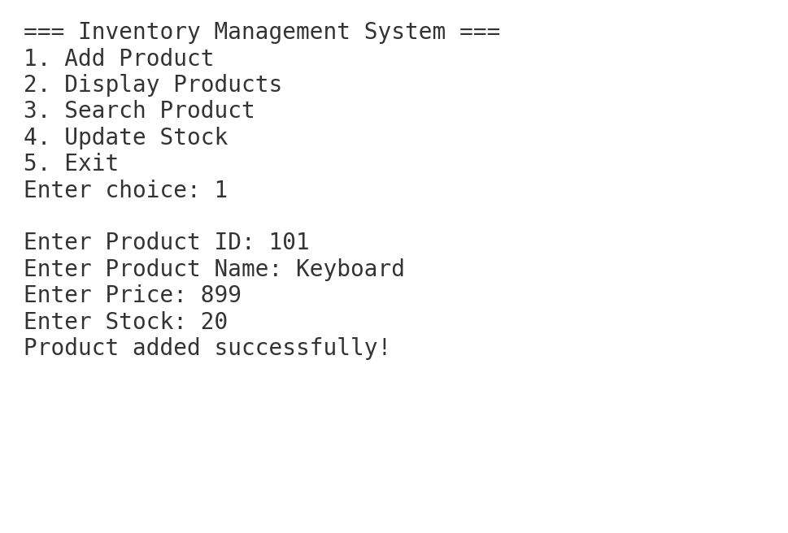

9. Conclusion
The Inventory Management System successfully demonstrates the use of structures, arrays, switch-case statements, and dynamic user interaction in C. It provides a smooth and functional inventory experience.

10. Future Scope
Future enhancements may include:
• File handling for permanent storage
• Product deletion feature
• Sorting by ID, name, or price
• GUI-based system
• Admin login functionality

